RESOLUTION NO.__________

RE: CERTIFICATE OF APPROPRIATENESS UNDER THE
PROVISIONS OF THE ACT OF THE PENNSYLVANIA
LEGISLATURE 1961, JUNE 13, P.L. 282 (53
SECTION 8004) AND BETHLEHEM ORDINANCE NO.
3952 AS AMENDED.

The applicant proposes to replace non-historic doors at the rear of the building at
11 W. Market St.

NOW, THEREFORE, BE IT RESOLVED by the Council of the City of Bethlehem that a Certificate of Appropriateness is hereby granted for the proposal.

Sponsored by: (s)

(s)

ADOPTED BY COUNCIL THIS DAY OF

(s)
President of Council

ATTEST:

(s)
City Clerk

HISTORICAL & ARCHITECTURAL REVIEW BOARD

The applicant proposes to replace non-historic doors at the rear of the building at 11 W. Market St.

APPLICATION #1:

Moravian Academy
4313 Green Pond Road
Bethlehem, PA 18020

OWNER:

__________________________________________________________________________

The Board upon motion by Marsha Fritz and seconded by Beth Starbuck adopted the proposal that City Council issue a Certificate of Appropriateness for the following:

- New doors to be mounted in a steel frame.

2. Doors will be a durable bronze finish.

3. The motion was unanimously approved.

__________________________________________________________________________

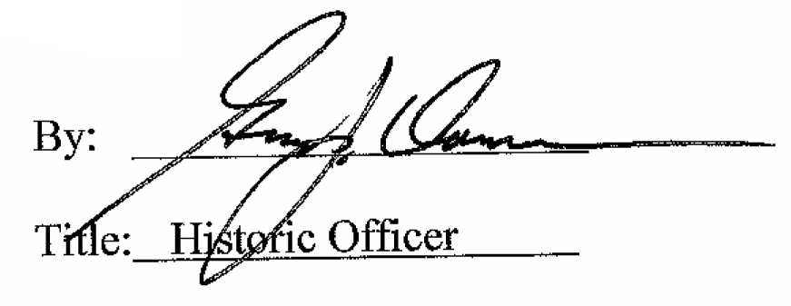

Date of Meeting: August 1, 2018

